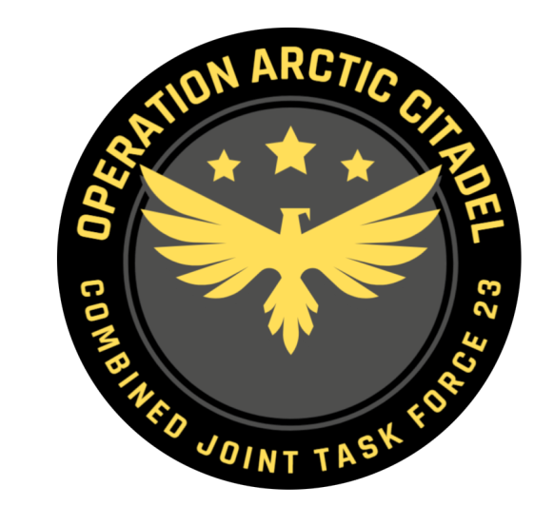

CJTF-23 OPERATION ORDER

OPERATION ARCTIC CITADEL

# SITUATION

## General situation

Notia have over years claimed part of Northern Finland as part of Notia after WW2.

The last year Notia have increased their posture toward Finland and had public statement regarding protecting Notian nationals in Notian claimed territory in Northern Finland while also expressing offensive ambitions and need to create strategic depth and move defenses forward.

Notia have expressed concern about the Notian nationals living in Northern part of Finland and have urged UN to protect their rights.

Notia have expressed a willingness to intervene to protect Notian nationals everywhere in the world.

The last 3 weeks we have seen a buildup of military forces in Notia indicating higher activity than normal. Notia have stated that this is part of their national exercise FROST. The exercise is scheduled to last until 23rd of September 2011

## Friendly situation

### Land Component Command (LCC)

Land Component Command consists of one allied Corps: IV Corps consisting of 55th Mechanized Division and 56th Armored Division. The LCC are currently in transit from Norway and Sweden into Finland. It is expected that first elements of LCC is operational at D2.

Until the the LCC is in place, it is only Finish self defense forces that are in the region. These consist of infantry and M113s.

### Maritime Component Command (MCC)

Maritime Component Command consist of

* Carrier Strike Group-72 (CSG-72): USS Abraham Lincoln + 1x Ticondoroga
* Surface Action Group 1 (SAG-1): 1x Oliver Hazzard Perry + 1x Arleigh Burke

The maritime forces are current doing force integration south of Bodø and will be operational for tasking from D5.

Part of the airwing (F/A-18s and F-14s) are forward deployed into Finland under JFACCs authority.

### Joint Force Air Component Command (JFACC)

Joint Force Air Component Command consists of the 132nd Virtual Wing and external organizations participating. Air bases available are Bodø, Andøya, Bardufoss and Banak in Norway. In Finland the following bases are available: Rovanemi, Kemi Tornio, Ivalo, Kittila, and roadbase Vuojarvi.

E-3 (3x E-3) and Tanker squadrons (4x KC-135 and 4x KC-135 MPRS) are arriving in the area of operations and are getting ready to support operations (locations for the various squadrons will be based on JFACC planning). In addition to all the aircraft, a Patriot Battalion with two Patriot Batteries is also attached to JFACC.

### Special Operations Component Command (SOCC)

Special Operations Component Command consists of 4 Special Operations Task Groups based in Finland.

## Enemy situation.

### Notian Army

* 1st Corps have left bases and are in training area conducting exercise FROST.
* 2nd Corps have partially left base complex and are taking part in exercise FROST.
* 3rd Corps have left bases and are in training area conducting exercise FROST.
* 4th Corps are currently not mobilized and are at homebase.

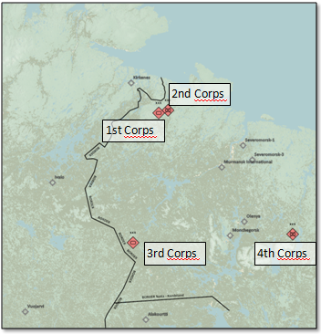

### Notian Air Force

Notian aircrafts have been conducting CAP missions in Notian airspace. Notian aircraft have also taken part in exercise FROST, both for strategic bombing and support to the land forces.

### Notian Naval Forces

The Notian Navy has mostly spent the last months in port conducting maintenance. The last weeks we have seen increased activity at the piers, and several ships seem to have loaded up with stores and ammunition. Early on the morning the 20th September the Pyotr Velikiy Surface Action Group (SAG) left port and were reported 130nm NORTH of the Kola Fjord

### Enemy Most Likely Course of Action (ML COA)

Notia will likely continue their force buildup to the culmination of exercise FROST. On completion of the exercise, Notia will try to get some diplomatic concessions, but will withdraw back to home bases within a few days. During the last phase of exercise FROST it is likely that WMD will be demonstrated.

### Enemy Most Dangerous Course of Action (MD COA)

Notia will in the MD COA conduct a combined land and air attack toward the Northern part of Finland, while they use their Navy to establish a perimeter to prevent aircrafts coming in from the NORTH. Defenses may be forward staged to make it harder for Finland and CJTF-23 to defeat Notian forces.

# MISSION

CJTF-23 will deploy to the area of operations (AO) and deter Notian offensive ambitions in order to (IOT) secure Finnish territorial integrity.

On Order (O/O) CJTF-23 will neutralize Notian offensive capability IOT contribute to a secure and stable environment, which will facilitate a lasting peace and render future allied military unnecessary

# EXECUTION

## Commander CJTF-23 intent.

### Purpose.

The purpose of this operation is to support Finland in deterring Notian aggression and if necessary defeat Notia.

### Endstate.

Finish territorial integrity secured. Notian will and ability to conduct offensive operations in the region neutralized.

## CONCEPT OF OPERATIONS

Operation ARCTIC CITADEL will be conducted in 4 phases:

Phase 1: Deployment

Phase 2: Deter

Phase 3a: Defend

Phase 3b: Decisive action

Phase 3c: Contingency

Phase 4: Stabilization

### Phase 1:

Deploy forces to the region, collect intelligence build situational awareness of the situation and defend Finland from Notian aggression.

### Phase 2:

Deter Notia from conducting an attack against Finland. Conduct training to show offensive capability, while collecting intelligence and DCA to protect Finland airspace

### Phase 3a:

If deterrence fails and Notia conducts an offensive, defend Finnish territory and set conditions for phase 3b.

### Phase 3b:

Attack Notian forces within Notia in order to neutralize Notian offensive capability.

### Phase 3c:

If required, conduct necessary attacks to reduce Kambiland ability to interfere with the campaign.

### Phase 4:

Once Notian offensive capability is neutralized, focus will shift to stabilize the situation and prepare for transition back to a situation where all actors respect the recognized international borders.

## OBJECTIVES

CJTF-23 has the following objectives:

1. Deny Notian attack on Finland
2. Establish air superiority over Finland
3. O/O Establish air superiority over Notia
4. O/O Establish air superiority over Kambiland
5. O/O Neutralize Notian offensive capability
6. O/O Destroy Notian WMD program
7. O/O Free allied prisoners located in SRNTGT044 - Directorate of National Security and Intelligence secret facility IVO POLIARNIE
8. Reduce influence from insurgent and terror groups in the region

## TASKS:

### Land Component Command (LCC):

COM LCC will:

* Build up forces in Finland
* Defend if necessary, Notian offensive toward Finland
* On order (O/O) conduct ground offensive into Notia in order to neutralize Notian capability to conduct offensive operations.

### Maritime Component Command (MCC):

COM MCC will:

* Maintain sea control in order to prevent any interference in CJTF-23 operations.
* Secure SLOC (Sea Lines Of Communication) into Norway

### Joint Force Air Component Command (JFACC):

COM JFACC will:

* Establish and maintain air superiority over Finland.
* Establish and maintain air superiority over Notia for phase 3
* Set conditions for LCC ground offensive into Notia in phase 3
* Plan, organize and execute targeting on behalf of CJTF-82.
  + Conduct AI campaign to break the Notian capability to conduct offensive operations.
* Support CJTF-23 with air support as requested throughout the operation.
* Plan for CSAR operations for downed pilots
* Plan for a hostage rescue operation to free prisoners located within the secret facility SRNTGT044

### Special Operations Component Command (SOCC):

COM SOCC will conduct full spectrum special operations in order to :

* Support CJTF-23 targeting in all phases
* Support counterinsurgency (COIN) operations
* Support for counterterrorism (CT) operations
* O/O conduct hostage rescue of prisoners in SRNTGT044
* O/O conduct CSAR of downed pilots

### Virtual Intelligence Service (VIS)

VIS will:

* Handle intelligence on behalf of CJTF-23
* Support JFACC with intelligence products as required
* Support JFACC with recommendations to targeting campaign

# ADMINISTRATION AND LOGISTICS

Resupplies will primary be shipped in via sea lines of communication (SLOC). Priority resupplies may be flown into Finland or Norway.

Due to other major military operations taking place at the same time, certain high demand ammunition items may be temporarily unavailable.

Current limitations on ammunition:

* AGM-84D (Harpoon):**50** (F/A-18)
* AGM-84E (SLAM):**10** (F/A-18)
* AGM-84H (SLAM ER):**6** (F/A-18)
* AGM-154A:**15** (F/A-18, F-16)
* AGM-154C:**6** (F/A-18)
* GBU-31(V) 3/B (Bunker buster): **10** (F/A-18, F-16, A-10)
* GBU-31: **20** (F/A-18, F-16, A-10)
* GBU-32:**15** (F/A-18)
* GBU-38: **50** (F/A-18, F-16, A-10)
* GBU-54: **20** (A-10)
* GBU-10:**15** (F/A-18, F-14, F-16, A-10)
* GBU-12:**50** (F/A-18, F-14, F-16, A-10)
* GBU-16:**0** (F/A-18, F-14)
* GBU-24:**15** (F/A-18, F-14)

All other ordnance is unlimited. Request for specific ordnance can be forwarded to CJTF HQ (Mission designer). Depending on the situation, expect between 1-6 events from ordnance is requested until it is available.

# COMMAND AND CONTROL

CJTF-23 HQ located at Bodø Airbase, Norway.